**5.8 INTRODUCTION OF RC5 BASED REMOTE CONTROL SWITCHING SYSTEM**

As we know technology is developing day by day. Every where we see remote operated devices are replacing the ordinary switching/ controlling methods. It also proves itself a very cheap and effective way to control the devices, but when we see our rooms or our houses we are still using the ordinary methods of switching to control all the home appliances. So we developed the RC5 protocol based device which can easily replace the ordinary switching board. Which works on Manchester coding and this device enables us cotrolling our devices conviently.

**5.9 RC5 REMOTE DECODER SERIAL OUT**

The RC5 remote decoder board is based on the IC ST3617 which decodes the received  
remote control data and output 16 bit serial data output. The decoded data contains  
various information like Toggle Bit, Address of Remote and Command Key Pressed. This decoded information from transmitter can be used in various ways to make any remote controlled application. The transmitter should be a RC5(Philips) protocol type normally found in house hold TV remote controls.Custom RC5 transmitter can be designed using SAA3010 IC

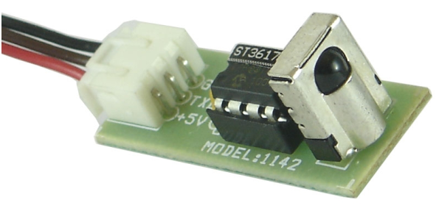

Fig :-RC5 remote decoder serial out

**5.10 BLOCK DIAGRAME**

ST3617 needs only one component to work that is IR receiver like TSOP1738 or similar. The data isoutput as simple 2 bytes of serial data consisting of 16 bits of information for each key press on theremote.

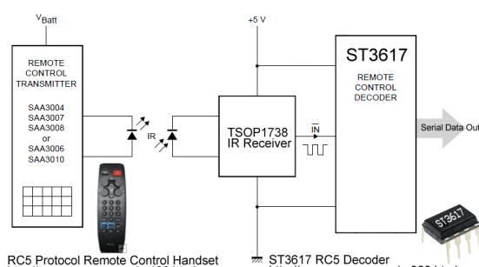

Fig :Block diagram of RC5 remote control handset and RC5 decoder

**5.11 PHILIPS CHIP RC5 PROTOCOL**

Let us review the RC5 protocol to understand the RC5decoder IC ST3617 better. The RC5 code from Philips ispossibly the most used protocol by hobbyists, probablybecause of the wide availability of cheap remote controls. The protocol is well defined for different device typesensuring compatibility with your whole entertainment system.

FEATURES OF PROTOCOL5 bit address and 6 bit command lengthBi-phase coding (aka Manchester coding)

Carrier frequency of 36kHz or 38kHzConstant bit time of 1.778ms (64 cycles of 36 kHz), Different timing for 38Khz

**5.11 MODULATION**

RC5 Modulation The protocol uses bi-phase modulation (or so-called Manchester coding) of a36kHz IR carrier frequency. All bits are of equal length of 1.778ms in this protocol, with half of the bit time filledwith a burst of the 36kHz carrier and theother half being idle. A logical zero isrepresented by a burst in the first half ofthe bit time. A logical one is represented by a burst in the second half of the bit time. Thepulse/pause ratio of the 36kHz carrier frequency is 1/3 or 1/4 which reduces power consumption.

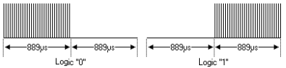

Fig :- Graph of RC5 modulation

**5.12 OUTPUT DATA FORMAT**

Output from ST3617 is in two bytes, thus making total 16 bits of data, let us see meaning of each bit A4-A0 = RC5 address of remote control, For TV remote this is zero. D5-D0 = RC5 command for each keypress at remote control. For Key 1 its 1, Key 2 = 2 and such, Find a table on last of this datasheet showing key value for each key press

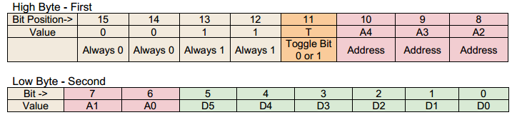

**5.13 SCHEMATIC DIAGRAM OF INTERFACING OF RC5 WITH 8051 MICROCONTROLLER**

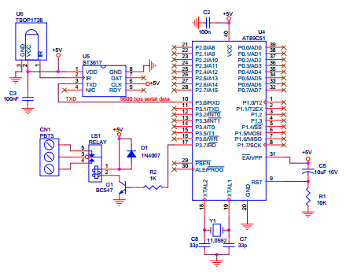

Fig5.9:-schematic diagram of interfacing of rc5 with 8051 microcontroller

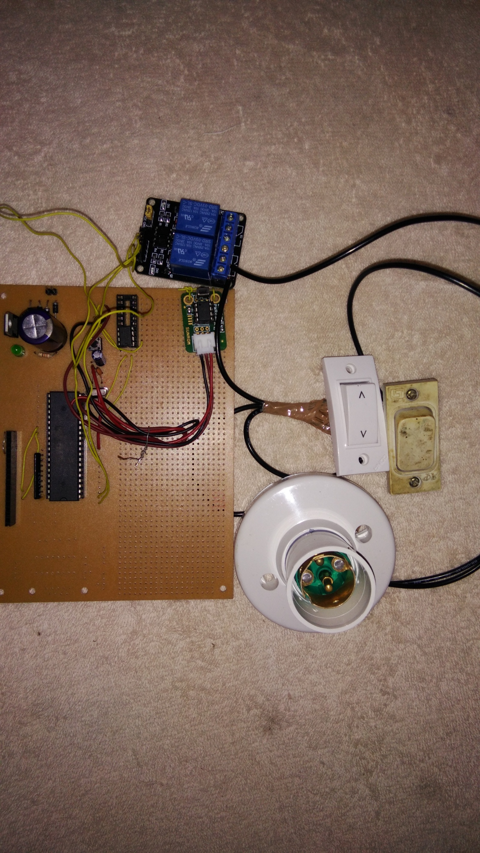

Fig 5.10 Project image

**CHAPTER-6**

**REFERENCES**

[1]<http://arshbir.com/>

[2] <https://en.wikipedia.org/wiki/Internet_of_Things>

[3] <https://forum.arduino.cc/index.php?topic=283043.0>

[4] <http://www.instructables.com/id/Controlling-AC-light-using-Arduino-with-relay-modu/>

[5] <http://arshbir.com/lightctl/>